# USER MANUAL

When prompted, the user must enter his or her weight in pounds. The weight must be an integer and must be greater than or equal to 1 pound, and less than or equal to 812 pounds (the heaviest man alive). After that, the user must input an integer representing the time in minutes since it has been since his or her last drink. This number can be anywhere from 0 to 1440 (the number of minutes in 24 hours). After that the user will be prompted to enter their gender as ‘M’ or ‘F’. Once that is over the program will print out a summary of the user’s information and begin printing out the BAC Chart!

# SYSTEM MAUNAL

The program is based off 5 functions that are included in the cpp file. The calculations are based off the assumption that 1 drink is equal to a 12oz Beer, 1.25oz Liquor, or 5oz Table Wine. The BAC will reduce at a speed of 0.01 per 40 minutes. The constants used in the program is 4.5 for females and 3.8 for males. The equation used to calculate BAC is:

# drinks * constant

weight

= BAC

0.01 * (minutes since last drink)

40 minutes

-

The program will take a user’s weight, gender, and duration since last drink to calculate BAC. The BAC will be calculated for a certain number of drinks. The program will create a table with the BAC for drinks 0 through 10 and will list the level of impairment associated with each BAC. Here is the chart for the impairments for BAC levels:

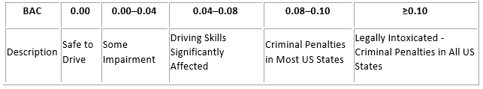

Any BAC over 0.30 is considered a health risk that can cause fatality.